Final Project (Group 2)
Comparative Analysis of Machine Learning Techniques for Red Wine Quality Classification

Hongyi Zhang¹, Mengqi Liu¹, and Aoyu Liu¹
¹McKelvey School of Engineering, Washington University in St. Louis, USA
hongyi.zhang@wustl.edu, liumengqi@wustl.edu, aoyu@wustl.edu
Instructor: Professor Jinsong Zhang

Introduction
The objective of this project is to use machine learning techniques to classify red wine quality, with a focus on exploring the performance of different classification algorithms in this task. Machine learning is one of the core methods of modern data analysis, capable of predicting or classifying new data by learning patterns in existing data. By training and evaluating the model, we can determine the best way to improve prediction accuracy. This project selected the Wine Quality Dataset from UCI machine learning database. The dataset contained 1,599 records of red wine, each of which included 11 chemical attributes (fixed acidity, volatile acidity, citric acid, residual sugar, chlorides, free sulfur dioxide, total sulfur dioxide, density, pH, sulphates, and alcohol) and a target variable (quality).

The goal of this dataset is to predict the quality score of a red wine (ranging from 3 to 8). To simplify the task, we transform the original multi-classification problem into a binary classification problem, labeling samples with a quality score greater than or equal to 6 as "high quality" (label 1) and samples with a quality score less than 6 as "low quality" (label 0).

The objectives of the project include:
- A variety of machine learning models, including decision tree, random forest, support vector machine (SVM), and artificial neural networks (ANN), were used to make classification predictions for red wine quality.
- Compare the performance of different models in classification tasks and evaluate their accuracy, accuracy, recall, and F1 scores.
- The advantages and disadvantages of the model are analyzed through the experimental results, and the best classification method suitable for the data set is determined.

We used the following four classification algorithms in the project:
- Decision Tree: By constructing a decision tree to classify data points.
- Random Forest: Use multiple decision trees for ensemble learning to improve classification performance and reduce overfitting risks through voting mechanisms.
- Support vector machine (SVM): Used for classification tasks that finds the optimal hyperplane to maximize the margin between data points of different classes.
- Artificial Neural networks (ANN): Fully connected neural networks are used to model complex input-output relationships through nonlinear activation functions.

Exploratory Analysis of the Dataset

Missing Value and Outliers Detection
Before conducting data analysis and visualization, it is necessary to check for missing data to avoid issues during the analysis process. Upon inspection, it was found that there are no missing values in the dataset.

After performing the missing value check, the next step is to detect outliers in the data and visualize them using boxplots. Below is a boxplot visualization of 12 numerical categories.
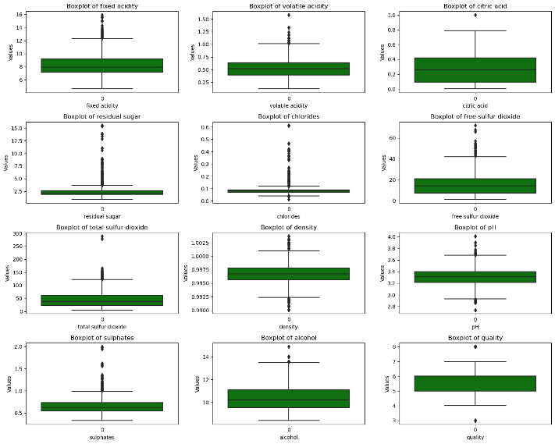
Figure 1: Boxplots of Red Wine Dataset
From the above figure, it can be observed that some features exhibit significant skewed distributions and outliers, such as residual sugar, chlorides, and sulphates. To reduce the impact of poor data distribution on the model, the StandardScaler method from sklearn package will be used to standardize the training and test sets separately after splitting the data. This helps improve the data distribution. Standardizing after splitting the dataset is done to prevent data leakage and to enhance the robustness of the model.

Basic Statistical Analysis
The basic statistical analysis is a statistical inspection of the 12 numerical variables. The table below provides the statistical information for them, which provides some outlines of these data.
Table 1: Basic Statistical Information about features
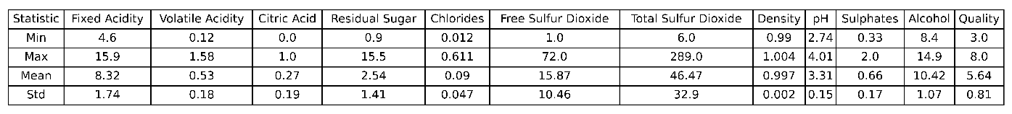

Data Distribution
Afterward, we can use histograms to observe the distribution of these data. The distribution plots are shown below.
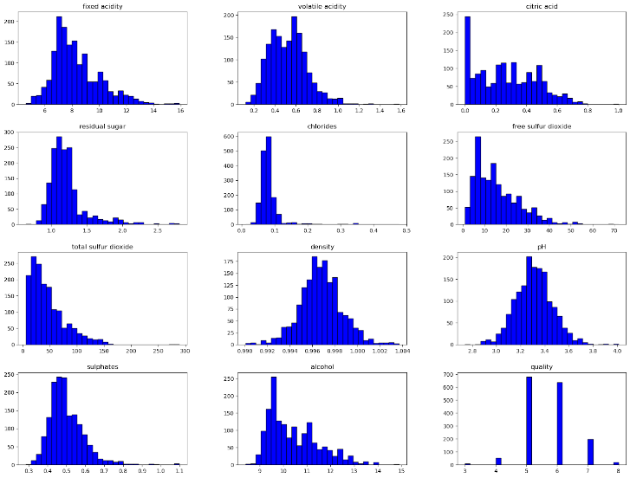
Figure 2: Distributions of Red Wine Dataset
Combining the information from the above images and the above tables, we can visualize the overall status of the data more clearly.

Feature Correlation Analysis
To more intuitively observe the relationships between the feature values, we plotted the correlation matrix of the features. From the heatmap, it can be seen that the overall correlation between the features is relatively low, and therefore, dimensionality reduction is not necessary.
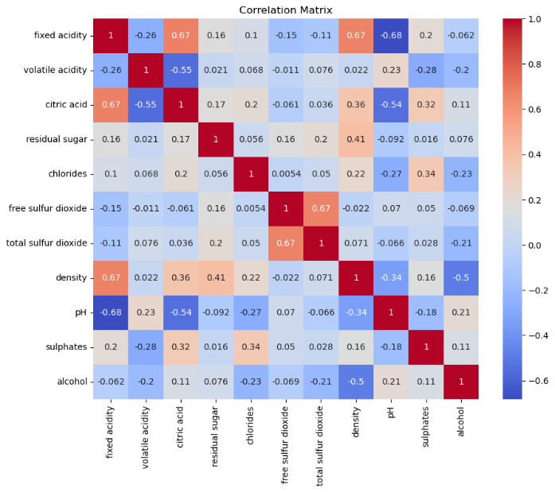
Figure 3: Correlation Matrix of Red Wine Features

Methods

Decision Tree
Decision tree is a commonly used supervised machine learning method, widely used in classification problems. Its core is to divide the data step by step by a series of bifurcation splits or multifurcation splits based on features, always forming a decision path from the root node to the leaf nodes. In the classification task, the decision tree maximizes the purity of the leaf nodes by choosing the features and thresholds that best differentiate between the targets at each node. And calculate the impurity by computing Entropy or Gini Index. Finally, calculate the Information Gain for different classifications and select the maximum case to determine the feature type and threshold for splitting.

Baseline Model of Decision Tree
In this study, we first trained a baseline decision tree model as a reference for benchmark performance. The baseline model used the default parameters of decision tree classifier. The criterion was set to "entropy" and the random state was set to 0.

During the construction of the baseline model, the training set was used for model fitting, and predictions were made on the test set to obtain the classification metrics of the baseline model, which contain overall accuracy, precision, recall, and f1-score.

Hyperparameter Tuning and Cross-validation of Decision Tree
Key hyperparameters included:
- criterion: The function to measure the quality of a split (e.g., 'gini', 'entropy').
- max_depth: The maximum depth of the tree, controlling its complexity and preventing overfitting.
- min_samples_split: The minimum number of samples required to split an internal node, influencing the granularity of splits.
- min_samples_leaf: The minimum number of samples required to form a leaf node, affecting the minimum size of terminal nodes.

To further enhance the predictive performance and generalization ability of the decision tree, we performed hyperparameter tuning using Grid Search and Cross-validation. By defining a parameter grid and using GridSearchCV to perform an exhaustive search, we evaluated the performance of each parameter combination on the training set using 5-fold cross-validation, allowing us to select the optimal parameter combination in terms of overall performance.

Random Forest
Random Forest is an ensemble learning method that improves overall predictive performance and robustness by combining the predictions of multiple decision tree models. During the training process, Random Forest employs bootstrap sampling and random feature subset selection to construct a set of independent and diverse decision trees. The final classification result is determined through voting on the predictions of individual trees. Compared to a single decision tree, Random Forest typically offers higher generalization ability and stability, and demonstrates strong resistance to overfitting.

Baseline Model of Random Forest
In this study, we trained a baseline Random Forest model using the default parameters of Random Forest Classifier. After training the model on the training set, we evaluated its performance on the test set, including metrics such as overall accuracy, precision, recall, and f1-score. This step provides a reference for comparison in subsequent hyperparameter tuning.

Hyperparameter Tuning and Cross-validation of Random Forest
Key hyperparameters included:
- n_estimators: The number of trees in the forest, controlling the ensemble size.
- max_depth: The maximum depth of the decision trees, determining the complexity of the individual trees.
- min_samples_split: The minimum number of samples required to split an internal node, influencing the granularity of the splits.

To further improve the predictive performance of the Random Forest model, we conducted a Grid Search combined with 5-fold cross-validation to tune its key hyperparameters. Specifically, we systematically searched for optimal values of parameters such as the number of trees in the forest, the maximum depth of the decision trees, and the minimum number of samples required to split an internal node.

In detail, we defined a parameter grid and used GridSearchCV to perform K-fold cross-validation on the training data, evaluating the performance of each parameter combination to identify the one that performs best on the validation set. This approach effectively enhances the model's generalization ability, reduces the risk of overfitting, and achieves better predictive results on the test set.

After identifying the optimal parameter combination, we used best hyperparameters to construct the optimized model. This model outperformed the baseline model on the test set, demonstrating the significant impact of appropriate hyperparameter tuning on performance improvement.

SVM
In this project, the Support Vector Machine (SVM) was employed as a classification model to predict red wine quality. The primary objective of SVM is to identify an optimal hyperplane to maximize the margin that effectively separates data points from different classes. To enhance the model's generalization ability, both a baseline SVM model and a hyperparameter-tuned model were implemented.

Baseline Model of SVM
The baseline model was implemented using default Support Vector Machine Classifier from sklearn package. And the model was trained on the training set and evaluated on the test set.

Classification performance was assessed using metrics such as accuracy, precision, recall, and f1-score.

Hyperparameter Tuning and Cross-validation of SVM
Key hyperparameters included:
- C: The regularization parameter, controlling the flexibility of the classification boundary.
- kernel: The type of kernel function (e.g., 'rbf', 'poly', 'linear').
- gamma: Kernel coefficient for non-linear kernels.
- degree: Degree of the polynomial kernel.

Grid search with cross-validation (GridSearchCV) was employed (cv=5) to identify the optimal parameter combination on the training set. The best parameters were extracted and used as the model's hyperparameters. The model was then retested with these parameters and evaluated on the test set.

ANN
In this project, the Multi-Layer Perceptron (MLP) was implemented to perform classification tasks. A baseline MLP model was implemented first to see its basic ability, and based on it a model after hyper-parameter tuning was implemented to reach a better accuracy of classification tasks.

Baseline Model of ANN
An initial MLP Classifier model was created with default parameters, a maximum iteration of 2000, and a fixed random state for reproducibility. The model was trained on the training dataset and the evaluations were generated based on the test set. To evaluate the performance, accuracy, precision, recall, F1-score and confusion matrix were applied to have a comprehensive result.

Hyperparameter Tuning and Cross-validation of ANN
A detailed GridSearchCV approach was employed to optimize the hyperparameters of the MLPClassifier. The parameters tuned included:
- hidden_layer_sizes: The structure of the hidden layers in the neural network. Adjusting this parameter can control the complexity and expressiveness of the model.
- activation: Define the activation function used in the hidden layer. In the project the Rectified Linear Unit function was chosen.
- solver: Define optimization algorithm for weight update. In the project Adam algorithm was chosen.
- alpha: The L2 regularization parameter used to prevent overfitting.
- learning_rate: The learning rate adjustment strategy defines how the learning rate changes dynamically. In the project adaptive strategy was chosen to automatically adjust the learning rate based on training progress.
- learning_rate_init: The initial learning rate controls the step size of the weight update.

Based on these hyperparameters GridSearchCV was implemented to find the best parameter combination. Similar evaluations in 3.2.1 were chosen.

Results and Analysis

Desicion Tree

Baseline Model Result
For the baseline decision tree model, the precision is 0.72, the recall is 0.74, the f1-score is 0.73 and the accuracy is 0.7469 of low-quality red wine.

Result After Hyperparameter Tuning and Cross-validation
After performing hyperparameter tuning using Grid Search with 5-fold cross-validation, the best hyperparameters for the model were identified as criterion equals to entropy, max depth equals to 6, min samples leaf equals to 12, and min samples split equals 2. Based on this tuned model, for low quality red wine, the precision is 0.74, the recall is 0.72, the f1-score is 0.73, and accuracy is 0.7531

Random Forest

Baseline Model Result
For the baseline random forest model, we can calculate that the precision is 0.80, the recall is 0.82, the f1-score is 0.81, and the accuracy is 0.8219 of low-quality red wine.

Result After Hyperparameter Tuning and Cross-validation
After performing hyperparameter tuning using Grid Search with 5-fold cross-validation, the best hyperparameters for the model were identified as max depth equals to none, min samples split equals to 2, number of estimators equals to 200. Based on this model, for low quality red wine, the precision is 0.80, the recall is 0.82, the f1-score is 0.81, and the accuracy is 0.8250.

SVM

Baseline Model Result
For the baseline SVM model, we can calculate that the precision is 0.75, the recall is 0.74, the f1-score is 0.74, and the accuracy is 0.7625 for low-quality red wine class.

Result After Hyperparameter Tuning and Cross-validation
The best parameters identified were: C=5, kernel set to 'rbf', gamma set to 0.1, degree set to 2. The tuned model achieved a classification accuracy of 77.81%. The F1-score for Class 0 improved to 0.76, and for Class 1, it increased to 0.80. The macro-average and weighted-average accuracy rose to 0.78.

The tuned model's accuracy improved by 1.56% compared to the baseline model. Metrics such as F1-score and recall also demonstrated improvements. The confusion matrix indicates that the tuned model performed better in identifying high-quality wine, with fewer classification errors.

ANN

Baseline Model Result
The classification accuracy of the baseline MLP model was 76.56%. For low-quality red wine, the precision is 0.77, the recall is 0.71 and the f1-score is 0.74, and accuracy is 0.7656.

Result After Hyperparameter Tuning and Cross-validation
The optimal parameter combination was identified as alpha set to 0.001, hidden layer sizes configured as (100, 100), and the initial learning rate set to 0.01. The accuracy of the MLP model reached 79.69% after tuning.

For the two classes, all the three metrics were improved to 0.80, both in macro-average and in weighted-average. Comparing with the baseline model, for Class 0, all the three metrics improved. For Class 1, although the recall dropped for 0.03, the rest of the metrics were better as well.

Analysis
To simplify the comparison, we directly selected the simplest and most intuitive metric, accuracy, as the evaluation standard. The figure below shows the accuracy of the baseline and tuned models for each algorithm. This figure demonstrates that using GridSearchCV for hyperparameter tuning and cross-validation can effectively improve model performance. Among them, the tuned Random Forest model achieved the highest accuracy of 0.8250, highlighting that ensemble learning can enhance model performance.
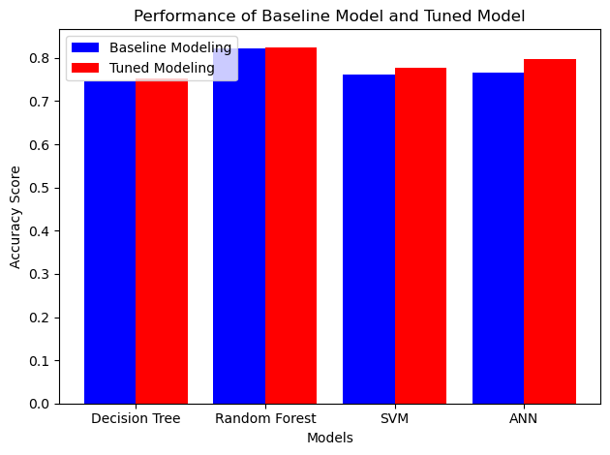
Figure 4: Performance of Baseline Models and Tuned Models

Conclusion
Through the previous results, it is shown that among the four methods, Random Forest had the best performance, with the accuracy of 82.5%. Compared with the baseline models, all the models had improvements after the Hyperparameter Tuning and cross-validation, which shows the importance of choosing proper parameters for different models. Furthermore, this demonstrates that ensemble learning can effectively enhance model performance. Even though in this project the target values were divided into two classes in order to have a higher accuracy, it could be further analysed in the future to see the reason why the original target values had a bad performance, and consider a wider range of hyperparameters to find better parameter combinations for a higher accuracy.

Work Distribution:
Hongyi Zhang: Exploratory Analysis of the Dataset, Decision Tree and Random Forest
Mengqi Liu: Introduction, Support Vector Machine
Aoyu Liu: Conclusion, Artificial Neural Network

Appendix

